**Estd. – 1914**

**FREE OPHTHALMIC HOSPITALS’ SOCIETY’S**

K. B. HAJI BACHOOALI CHARITABLE OPHTHALMIC

& ENT HOSPITAL

FOHS FULL FINAL - Copy.tif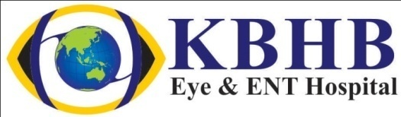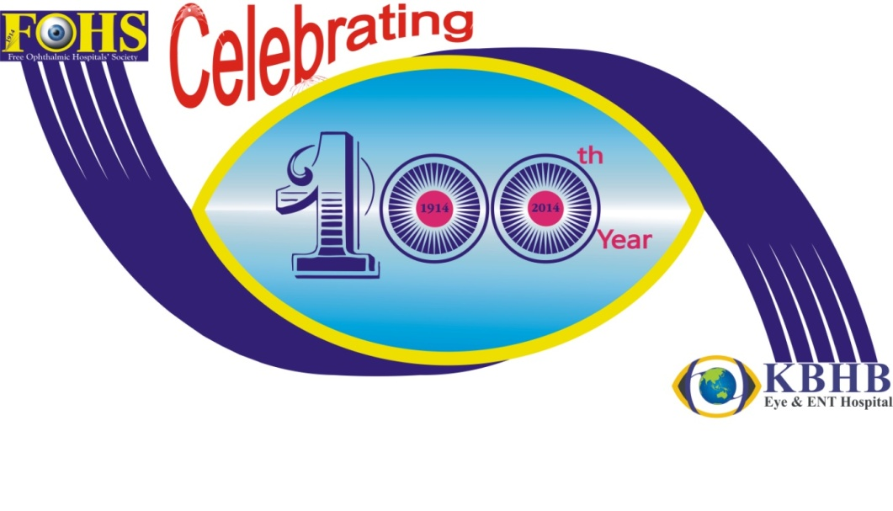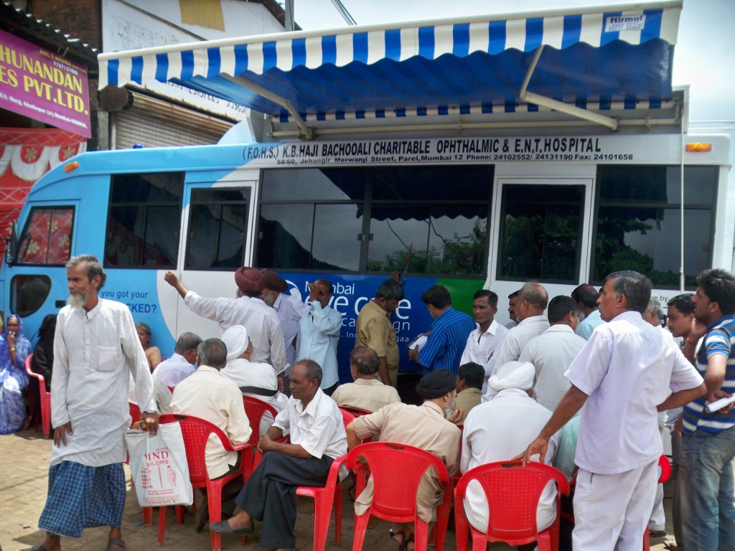

Reg. No. – 612 of 1939-1940 under Society Registration Act, 1860

Reg. No. F-348 (Bom) under Bombay Public Trust Act 1950

Registration No. 08378072 under foreign contribution act 1976

Donation exemption under section 80 G of income tax act 1961

Jehangir Merwanji Road, Parel, Mumbai

Ph – 022 – 24131190 / 24102552

Web - [www.kbhbhospital.com](http://www.kbhbhospital.com),

Email – [kbhb@rediffmail.com](mailto:kbhb@rediffmail.com)

[outreach@kbhb.org](mailto:outreach@kbhb.org)

**Excellence in Eye Care from 1914 with grand blessings of Father of the Nation Mahatma Gandhi, Dr. P. C. Alexander, Former Governor of Maharashtra**

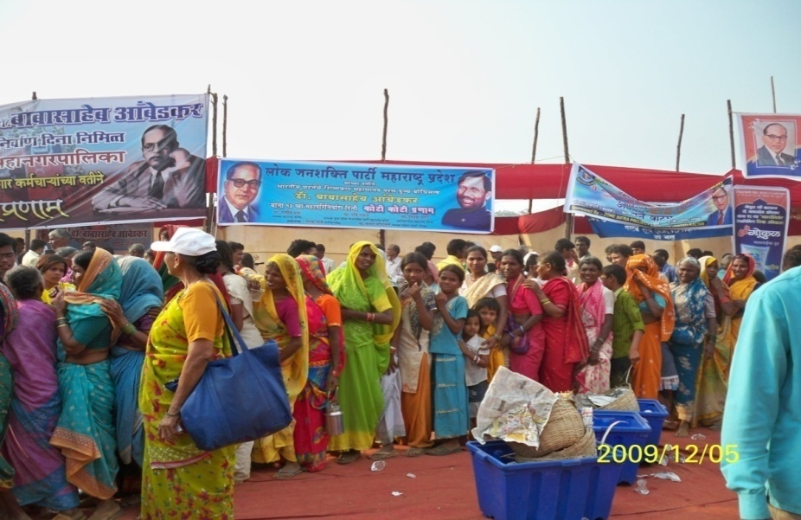

**Serving quality eye care for last 100 years**

The primary purpose of the outreach is to identify patients’ of curable blindness. The outreach program focuses mainly on making eye care facilities accessible to many poor patients as well as overall who cannot afford eye care due to their small budgets. It also focuses on making eye care available for isolated communities, which were suffer from poor infrastructure, and a low-density population, which prohibits the lack of eye awareness and facilities.

***“Outreach’ should be defined as the provision of a specialized service to a location outside the normal service catchments area of the Hospital.”***

The Outreach program conducted to identify potential patients based on diagnostic camps held at various locations in and around Mumbai, enabled the Hospital to motivate, persuade, and influence these patients to undergo necessary eye treatment which otherwise would have eluded them.

***The screening camps were organized for Pediatric as well as for adult peoples. Problematic patients were treated free of cost in the base hospital***

**KBHB Hospital’s Outreach Dept-**

The outreach dept was started in **1997** by the KBHB hospital’s management. The motivation behind establishing the outreach dept was from Arvind Eye Hospital, Madurai. In First year hospital had conducted **29 Diagnostic camps** from which **297 Cataract** patients were operated free of cost. This was just a beginning, Last year hospital had conducted **184 camps** from which **3124 cataract** operation were done free of cost.

**Reaching more than 4, 50,000 needy people from urban, rural and tribal area including adult and children through Base hospital and community outreach activities**

**Activities of Community Outreach Dept**

* Cataract Detection Camp
* Refraction Camps
* Primary Eye Care Center
* Vision Centers
* Fully Equipped Ophthalmic Mobile Van
* Awareness Campaign
* Training Center
* NGO-Networking
* Resource center

**Activities in Diagnostic Camps**

* Registration
* Vision Check Up by the team
* Examination by Doctors
* Refraction by Optometrist
* Spectacle counter (subsidized rates)
* Counseling

###### Diagnostic Camps (General)

These proposed camp activities were started with the objective to provide a facility in and around Mumbai to deal with eye problems especially for the deprived class of the society. With a view to help the under privileged community, Hospital has been doing cataract surgery FREE OF COST including travelling facility to hospital, Pre-operative investigations, food and stay for the patients coming from proposed camps conducted with the help of NGOs.

* 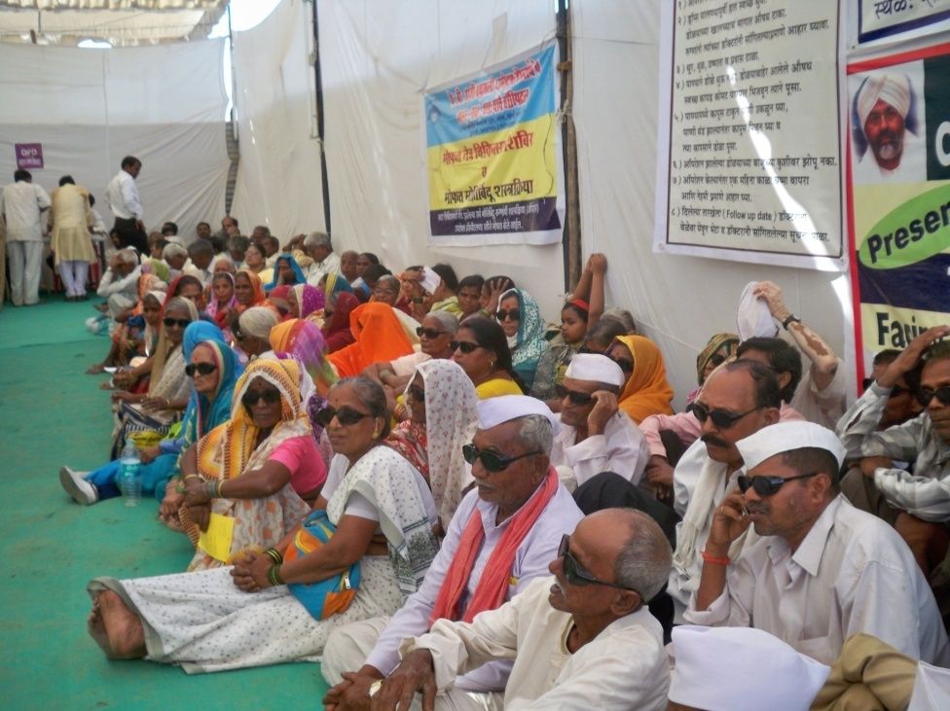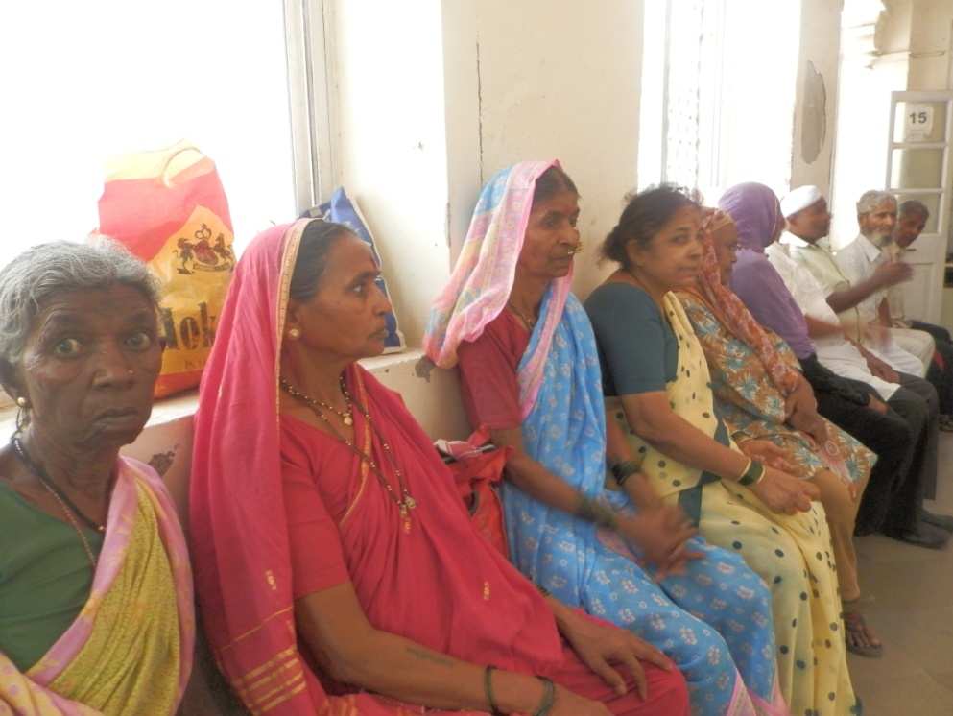With a view to help the under privileged community, our Hospital has been doing cataract surgery FREE OF COST including Pre-operative investigations, food and stay for the patients coming from proposed camps conducted with the help of NGOs. Under this scheme the NGOs or sponsoring agencies have to register their names with the hospital and fix the date for the camp and thereafter Hospital camp team will examine the patients at the campsite. The patients selected for surgery for surgery are brought to the hospital by the hospital MINI Bus and after the Surgery they are commuted back to their base camp site free of cost. Regular follow up done by hospital as well as NGO for drop out patients from the camp

|  |  |  |  |  |  |
| --- | --- | --- | --- | --- | --- |
| Performance of Eye Camp from April 2013 - March 2014 | | | | | |
| Sr. No. | Name of The N.G.O. | Total No. of Visits | Total No of Patients Screened | Total No of Patients Detected Cataract | Total No of Patient Operated Free |
| 1 | **Primary Eye Care Centre Shahapur** | **47** | 3115 | 1449 | 781 |
| 2 | **Shree Ballaleshwar Devsthan, Pali** | **9** | 821 | 432 | 288 |
| 3 | **Smt.Leenata B.Rele Charitable Trust, Alibaug** | **12** | 1102 | 662 | 420 |
| 4 | **Gram Vikas Arogya Sevabhavi Sanstha, Karjat** | **22** | 995 | 369 | 255 |
| 5 | **Shree Hariharputra Bhajan Samaj, Chembur** | **9** | 499 | 276 | 156 |
| 6 | **Khushiya Seva Sanstha, Worli** | **10** | 727 | 263 | 135 |
| 7 | **Centre For The Study of Social Change, Bandra** | **4** | 222 | 59 | 27 |
| 8 | **Sant. Nirankari Mandal, Mumbai** | **6** | 962 | 139 | 51 |
| 9 | **Mahaveer International, Santacruz** | **11** | 1455 | 343 | 151 |
| 10 | **Vasundhara charitable Trust, Palghar** | **8** | 277 | 57 | 13 |
| 11 | **Raje Group, Wada** | **10** | 165 | 20 | 10 |
| 12 | **Vision Centres, Mumbai (Mumbai Eye Care Campaign** |  |  |  | 619 |
| 13 | **Other Camps** | **36** | 5975 | 771 | 218 |
|  | **Total** | **184** | **16315** | **4840** | **3124** |

Performance from 1997 - 2014

**Facilities provided to the cataract patients from Camps –**

* Free of cost check up by the qualified and experienced Clinical team at their door step
* Free travelling facility from Camp site to Hospital and commute back to camp site after surgery
* Free accommodation in hospital during the surgery
* Pre – operative tests including HIV, Diabetics, HbsAg
* Free cataract surgery with IOL implant
* Provided post operative medicines
* Post operative follow ups
* Subsidized spectacles as per choice
* Pre and post operative counseling

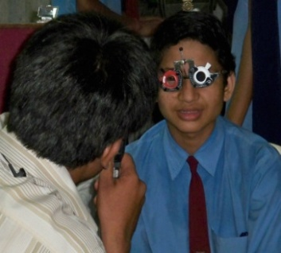

###### Pediatric Ophthalmology Unit-

###### KBHB hospital initiated the Pediatric Ophthalmic services in March 2003 with the support of Sight Savers as a dedicated unit catering to eye problems of children. It has become a referral center for children with eye diseases, from tertiary pediatric hospitals. A fully equipped, surgical theater was established. Thousands of pediatric surgeries performed every year. Some of the operation performed by our pediatric ophthalmic surgeons includes cataract extractions with intraocular lens implantation, squint correction, Keratoplasty and retinal surgeries. The new OPD of the year is 14011 and total 2313 surgeries were performed.

###### School Screening Program-

School screening program is a major step in Control of Childhood Blindness. In this activity we organize a camp in schools and diagnose the eye problems and refer them to the hospital for further treatment. The children identified to have eye problems are provided glasses, low vision devices and surgeries are done free of cost. Till date hospital have screened more than 3 lakhs of students and extended eye care services to more than 200 schools.

**Activities in Pediatric Outreach Dept**

* School Screening
* Pre-primary school screening
* Screening for socially handicapped children
* New Born Baby screening
* ROP Screening and Examination
* Training programs
* Awareness generation activities
* Referral system (Networking)

***“80% of the world’s blindness is avoidable, every five seconds one person in our world goes blind and a child goes blind every minute.”***

Hospital targets students from slums of Mumbai by organizing screening activities in Municipal and private schools from Mumbai and around sub-urban area and also from Tribal area from Shahapur Tahasil from Thane Dist. Hospital also reaches to the Anganwadis in Mumbai and suburban and provide awareness about eye care and eye health services to the children with the age group of 0-5 from slum. Hospital provides eye care services to the street children, orphanage, destitute, migrated construction workers children, commercial sex workers children, domestic workers, shelter homes, slum dwellers and one parenthood etc in association with Government and NGOs.

**NANHE School Eye Health Project** started in 2013 in association with Rotary Club of Bombay North. This Project will be for 2 years. Under this project 60000 students from schools of Mumbai Slums will be screened and examined. 6000 spectacles will be disbursed to the slum children. Those who require hospital based examination, treatment and surgeries will be provided free of cost in the hospital. In 2013 we have screened 27067 students, 990 free spectacles provided.

###### Newborn babies / ROP screening camp-

Hospital’s pediatric ophthalmic dept try to provide eye care services to the new born babies too. In partnership with various Govt maternity hospitals like KEM, Wadia and Sion Hospital organizes new born babies screening in the base hospital. All premature babies are examined by an pediatric ophthalmologist in the base hospital / NICU and those who require further clinical follow up will be provided at KBHB Eye Hospital for free.

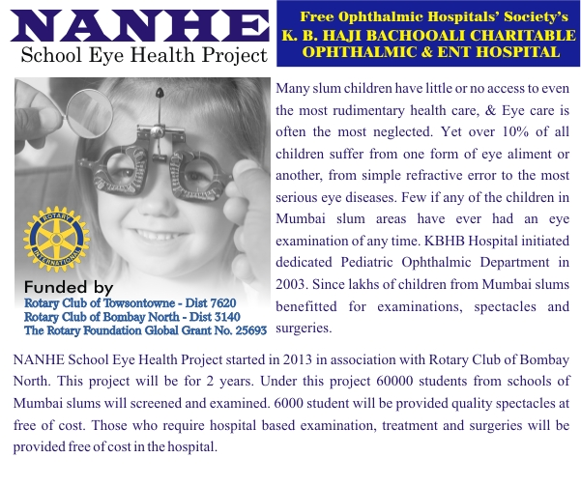

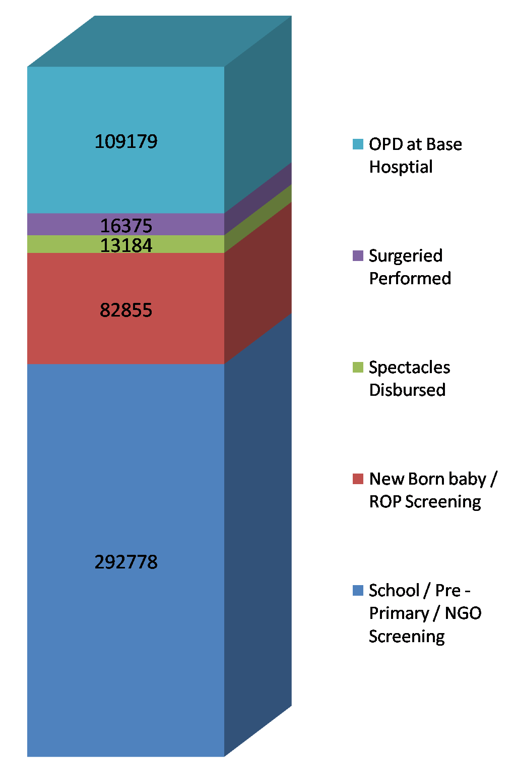

**Performance of Pediatric Dept from 2003 - 2013**

**“No Patient walks out of the Hospital without treatment for want of money”**

###### Picture12.png

###### Training Programs-

Hospital has also organized training programs for the teachers, community and social workers. The object for this program is to sustain the eye health education for the betterment of society. The training program includes various modules for teachers and health workers like; meetings, demonstration, practical etc. In this process parents are also equally participated.

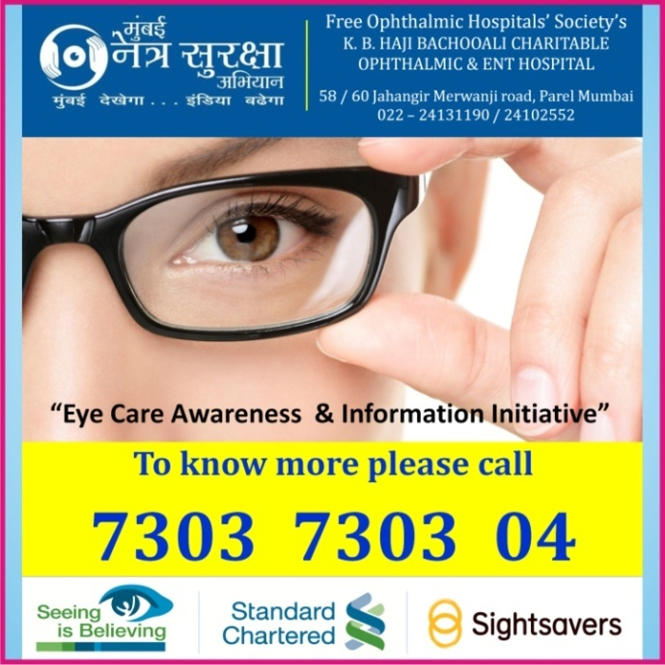**Awareness Campaign-**

To raise awareness of avoidable blindness by impressing upon community mind The message: 80% of the world’s blindness is avoidable, every five seconds one person in our world goes blind and a child goes blind every minute.

**Awareness generation Activities**

* Teachers and Parents Meetings
* Railway Boards
* Stickers
* Poster Exhibition
* Pamphlet Distribution
* Cable Network advertising
* Celebration of Various Days

**Collaborations with HospitalS & NGOs -**

Hospital has very good collaboration with majorly 3 biggest maternity homes like KEM, Wadia and SION hospital for providing quality eye care treatment to the neonates from the NICUs of the hospital for ROP. Our hospital team visits these maternity homes / hospitals periodically and examines the new born babies for ROP and general eye problems. Babies with problems are referred for further check and treatment in KBHB Hospital. A **NGO network** is a structure between NGOs, Trusts, religious institutions, Youth and Mahila mandals. A network in health sector is an asset for relevant ties between the Beneficiaries and hospital facilities. These NGOs which were registered with us will refer patients to hospital directly with their letter. Currently hospital is linked with more than 100 NGOs / Organizations in Mumbai

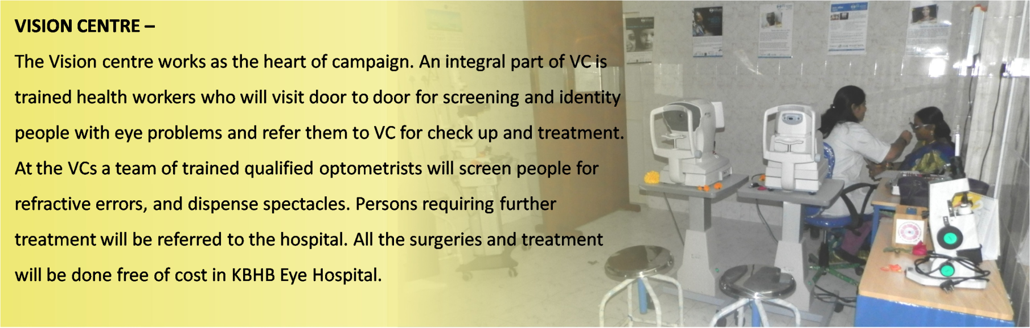

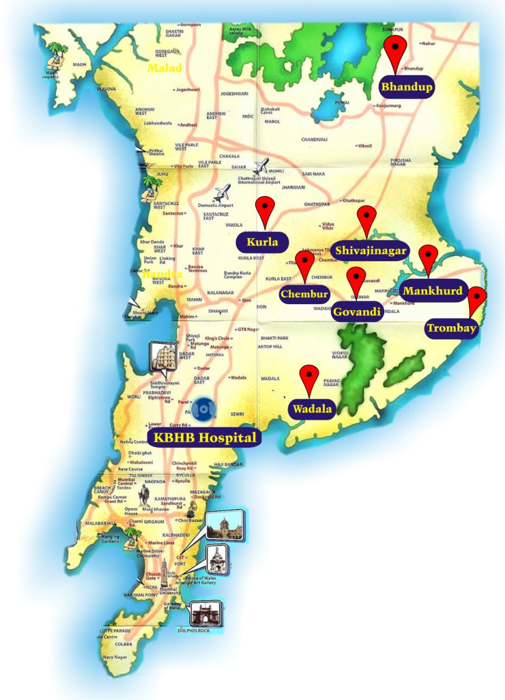**MUMBAI EYE CARE CAMPAIGN**

This campaign is an initiative of Hospital and Sight Savers under the ***“seeing is believing”*** project of Standard Chartered Bank. KBHB Hospital is a key partner of the campaign. The MECC campaign started April 2009 and terminated in June 2014. The campaign will have two fold strategy, one is to examine and treat 0.8 million for primarily for refractive errors and second is to create awareness in 8 different slum pockets about curable blindness.

Under this campaign hospital established 8 vision centers in Mumbai. All the Vision Centers and situated in the heart of slums of Mumbai at different slums. All the Vision centers are fully equipped and furnished for providing diagnostic eye care services. All the vision centers are opened once in week and the clinical team of the center provides quality primary eye care services at the center.

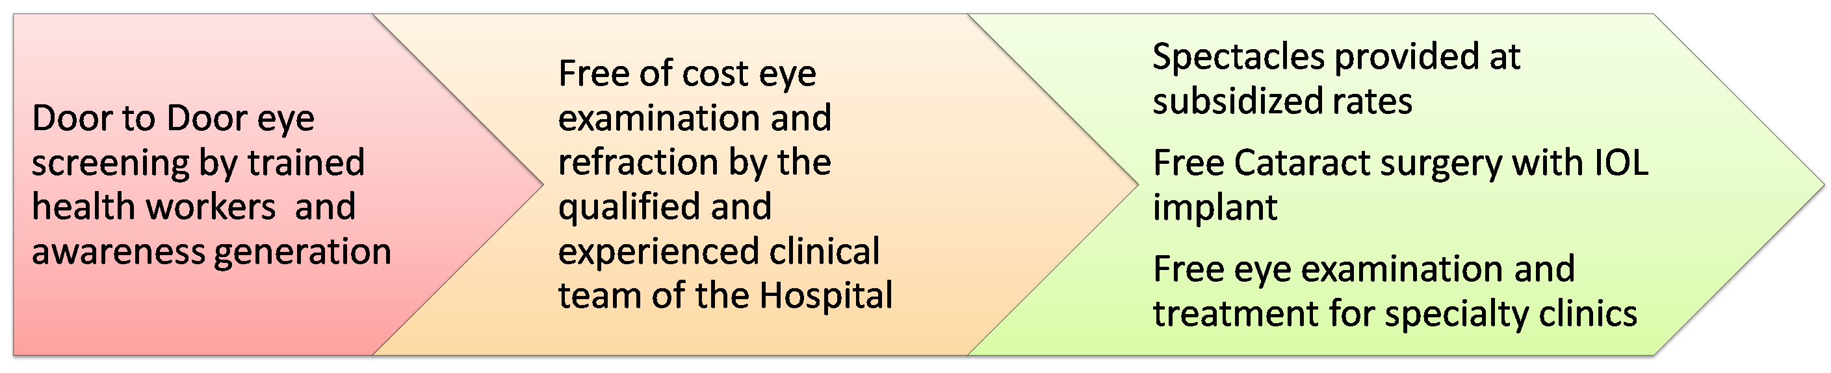**Services provided through Vision Centers**

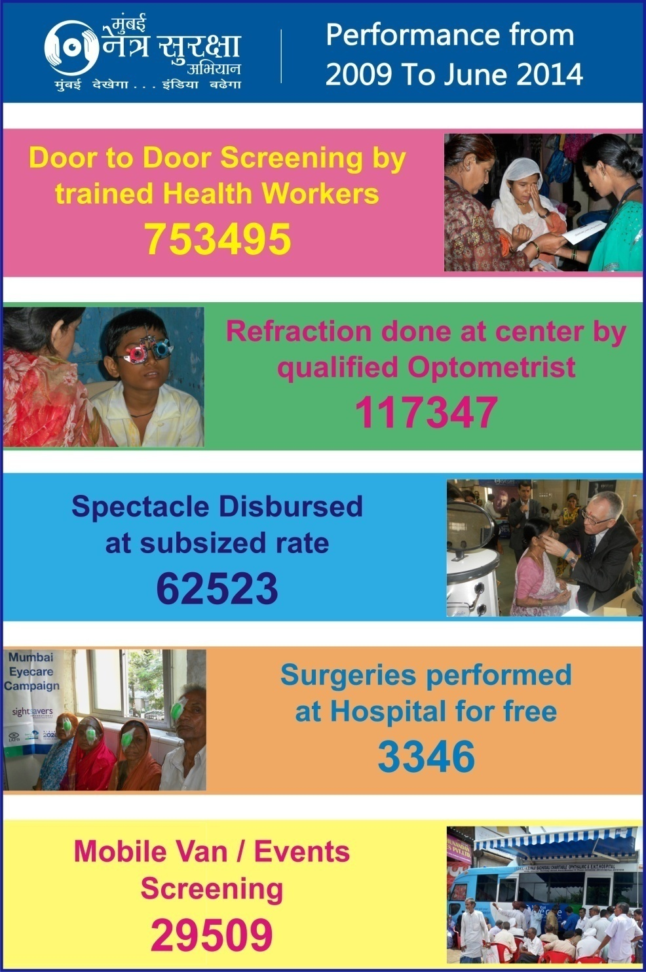**Mumbai Urban Eye Care Program (Nov 2014 – Oct 2015)**

This programme has been designed for a period of two years, with a goal of contributing in reduction of avoidable blindness among low income population in Mumbai. The aim of this programme is to **strengthen the Vision Centers** established under the Sightsavers’ supported Mumbai Eye Care Campaign (MECC) 2009 - 2014. Under this programme, focus will be laid on **creating awareness on eye care** and various eye conditions in eight slum pockets of Mumbai along with providing services for Refractive Errors (RE) and referral services for cataract and other eye conditions. Same kind of services will be providing to the patients as per the MECC project. The total target for screening for two years are 1, 34,400 while that for refraction is 19,200 and for dispensing spectacles is 9,216.

**Approach and activities under the program**

* Awareness generation
* Training of Community Health Workers (CHWs) and developing Volunteers
* Provision of Service through Vision Centre
* Referral for Secondary and tertiary services

**Mobile Van -**

**Fully Equipped Ophthalmic Mobile Van** inaugurated in February 2011 at Trombay. The van is donated by **The Christian Building Trust** under MECC project. This is AC van with all the necessary diagnostic equipments, which gives feel of an eye clinic. Average on a day 50 patients were examined by the clinical team of the van. The team includes optometrist, supervisor and Driver. This van is used for organizing eye check up camps for special focused groups – auto and taxi drivers, construction workers, police and RTOs etc, unions and associations, corporate, housing societies, school and colleges and many NGOs.

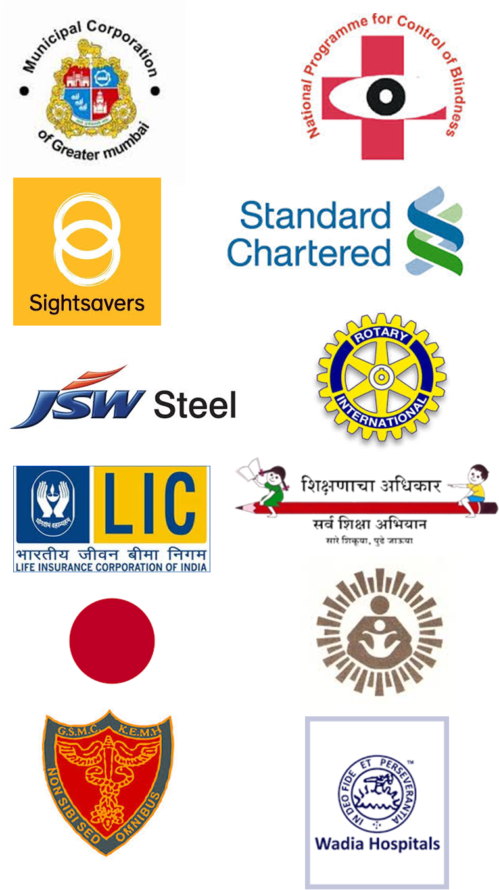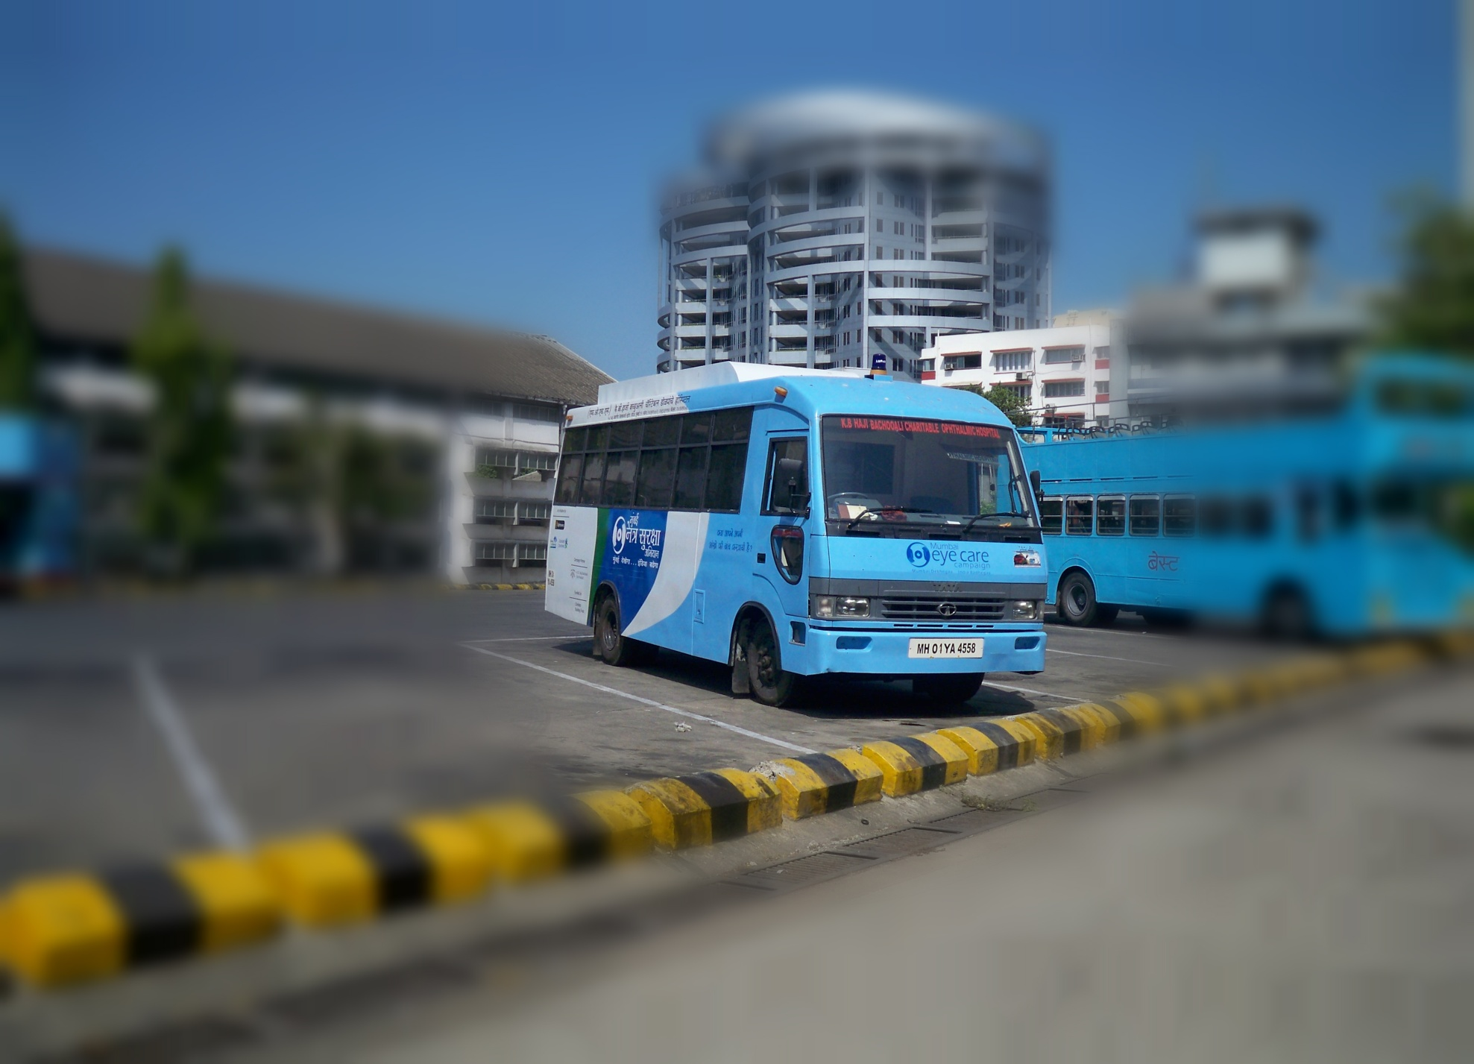**Our partners and supporters -**

**List of Advanced Equipments in the van –**

**Refraction chair unit**

**Slit lamp**

**Auto refractometer**

**Lensometer**

**Non Contact Tonometer**

**Indirect Ophthalmoscope**

**Retinoscope & Ophthalmoscope**

|  |  |  |
| --- | --- | --- |
| Sr. No | List of Vision / Primary Eye Care Centres | Area |
| 1 | Yashaswini Foundation | Shahapur, Dist - Thane |
| 2 | L. B. Rele Charitable Trust | Alibaug, Dist - Raigad |
| 3 | Advait Pratisthan | Nagothane, Dist -Raigad |
| 5 | Gramin Vikas Arogya Sevabhavi Sanstha | Karjat, Dist - Raigad |
| 6 | Paras Padmavati Jinshasam Trust | Dahanu, Dist - Thane |
| 7 | Khushiya Sanstha | Worli, Mumbai |
| 8 | Mahavir International | Santacruz, Mumbai |
| 9 | Centre for the Study of Social Change | Bandra (E), Mumbai |
| 10 | Vivan Education and Social Welfare Foundation | Mankhurd, Mumbai |
| 11 | Stree Mukti Sanghatana | Shivajinagar, Mumbai |
| 12 | Hariharputra Bhajan Samaj | Chembur, Mumbai |
| 13 | Kaushalya Mahila Vikas Sanstha | Bhandup, Mumbai |
| 14 | Samajik Sanstha Samnavay Samiti | Govandi, Mumbai |
| 15 | Vidya Vardhini Foundation Trust | Trombay, Mumbai |
| 16 | Shrusthi Organization | Wadala, Mumbai |
| 17 | Shradha Pratisthan | Kurla, Mumbai |

***“80% of the world’s blindness is avoidable, every five seconds one person in our world goes blind and a child goes blind every minute.”***